What are the kidneys?
The kidneys play key roles in body function, not only by filtering the blood and getting rid of waste products, but also by balancing levels of electrolyte levels in the body, controlling blood pressure, and stimulating the production of red blood cells.
The kidneys are located in the abdomen toward the back, normally one on each side of the spine. They get their blood supply through the renal arteries directly from the aorta and send blood back to the heart via the renal veins to the vena cava. (The term "renal" is derived from the Latin name for kidney.)
The kidneys have the ability to monitor the amount of body fluid, the concentrations of electrolytes like sodium and potassium, and the acid-base balance of the body. They filter waste products of body metabolism, like urea from protein metabolism and uric acid from DNA breakdown. Two waste products in the blood can be measured: blood urea nitrogen (BUN) and creatinine (Cr).
When blood flows to the kidney, sensors within the kidney decide how much water to excrete as urine, along with what concentration of electrolytes. For example, if a person is dehydrated from exercise or from an illness, the kidneys will hold onto as much water as possible and the urine becomes very concentrated. When adequate water is present in the body, the urine is much more dilute, and the urine becomes clear. This system is controlled by renin, a hormone produced in the kidney that is part of the fluid and blood pressure regulation systems of the body.
Kidneys are also the source of erythropoietin in the body, a hormone that stimulates the bone marrow to make red blood cells. Special cells in the kidney monitor the oxygen concentration in blood. If oxygen levels fall, erythropoietin levels rise and the body starts to manufacture more red blood cells.
After the kidneys filter blood, the urine is excreted through the ureter, a thin tube that connects it to the bladder. It is then stored in the bladder awaiting urination, when the bladder sends the urine out of the body through the urethra.
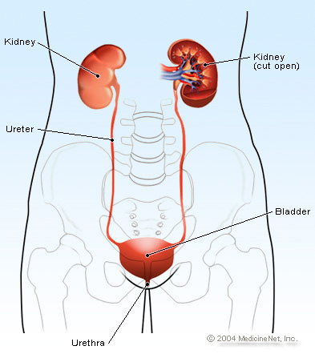

What causes kidney failure?
Kidney failure can occur from an acute situation or from chronic problems.
In acute renal failure, kidney function is lost rapidly and can occur from a variety of insults to the body. The list of causes is often categorized based on where the injury has occurred.
Prerenal causes (pre=before + renal=kidney) causes are due to decreased blood supply to the kidney. Examples of prerenal causes of kidney failure are:
- hypovolemia (low blood volume) due to blood loss;
- dehydration from loss of body fluid (for example, vomiting, diarrhea, sweating, fever);
- poor intake of fluids;
- medication, for example, diuretics ("water pills") may cause excessive water loss; and
- abnormal blood flow to and from the kidney due to obstruction of the renal artery or vein.
Renal causes of kidney failure (damage directly to the kidney itself) include:
- Sepsis: The body's immune system is overwhelmed from infection and causes inflammation and shutdown of the kidneys. This usually does not occur with urinary tract infections.
- Medications: Some medications are toxic to the kidney, including nonsteroidal anti-inflammatory drugs like ibuprofen and naproxen. Others potentially toxic medications include antibiotics like aminoglycosides [gentamicin (Garamycin), tobramycin], lithium (Eskalith, Lithobid), iodine-containing medications such as those injected for radiology dye studies.
- Rhabdomyolysis: This is a situation in which there is significant muscle breakdown in the body, and the damaged muscle fibers clog the filtering system of the kidneys. this can occur because of trauma, crush injuries, and burns. Some medications used to treat high cholesterol can cause rhabdomyolysis.
- Multiple myeloma
- Acute glomerulonephritis or inflammation of the glomeruli, the filtering system of the kidneys. Many diseases can cause this inflammation including systemic lupus erythematosus, Wegener's granulomatosis, and Goodpasture syndrome.
Post renal causes of kidney failure (post=after + renal= kidney) are due to factors that affect outflow of the urine:
- Obstruction of the bladder or the ureters can cause back pressure because the kidneys continue to produce urine, but the obstruction acts like a dam, and urine backs up into the kidneys. When the pressure increases high enough, the kidneys are damaged and shut down.
- Prostatic hypertrophy or prostate cancer may block the urethra and prevents the bladder from emptying.
- Tumors in the abdomen that surround and obstruct the ureters.
- Kidney stones. Usually, kidney stones affect only one kidney and do not cause kidney failure. However, if there is only one kidney present, a kidney stone may cause the lone kidney to fail.
Chronic renal failure develops over months and years. The most common causes of chronic renal failure are related to:
- poorly controlled diabetes,
- poorly controlled high blood pressure, and
- chronic glomerulonephritis.
Less common causes of chronic renal failure include:
- polycystic kidney disease,
- reflux nephropathy,
- kidney stones, and
- prostate disease.

